X Class

**L 200 154 004**

**RARA KINANDHA NINGRUM**

Database Management Systems

ER-Diagram is a model that aims to explain the relationship between data in the database based on the basic objects of data that have relationships between relations. And in the depiction of data structures and relationships between data, use some notations and symbols.

For this task, ER-Diagram will retrieve data from database named "Classicmodels". In it there are relationships between data such as Office tables against Employee table, table

ProductLines to the Products table, the Products table to the Order, the Order table against the Customers table, and the Customers table against

Employee table. Among the relationship data there is a relation that is

"One-to-One", "One-to-Many", and "Many-to-Many". But in ER-Diagram is only symbolized with 1: 1, 1: n, and n: n.

For more details, we can see the picture below.

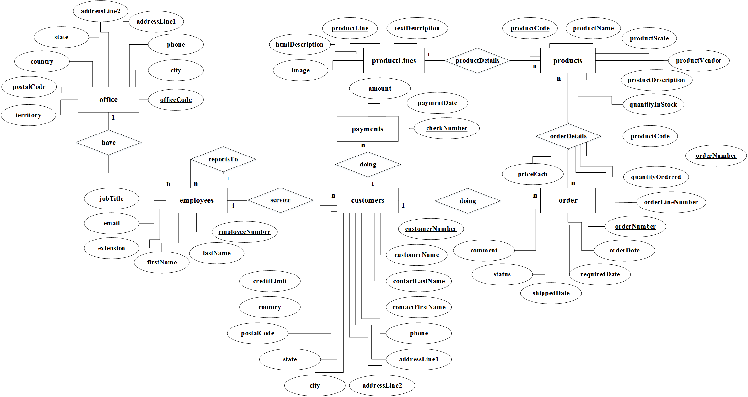

Keterangan :

1:1

=

One

-

to

-

One

1:

n

=

One

-

to

-

Many

n

:

n

/

n:m

=

Many

-

to

-

Many